

Technical & Tour Rider

- ADVERTISEMENT/BILLING OF ACT

Please bill the act as follows:
RUMOURS: The Ultimate Fleetwood Mac Tribute Show

Only photos/videos approved by RUMOURS Management are acceptable for use in any and all advertising and promotion. You may of course design your own graphics in a different style as long as the billing and imagery are correct.

- SOUND, LIGHTING AND STAGE PRODUCTION

Presenter shall furnish a sound and light system specifically designed to provide superior quality production.

For outdoor shows, artist requires a roof over the performance. Roof can be securely fastened tent structure as well.

Please note: A 70’s “vintage” look is preferred for all equipment.

- BACKLINE

Drums:
Ludwig or Yamaha
5 Piece kit

Kick 22”
Rack 12”
Rack 13”
Floor tom 16”
(2) snares Black beauty or equivalent 6.5 X 14
Hi hat stand
(4) cymbal stands
(2) Snare Stands
Fresh Remo coated ambassador heads if possible

Cymbals:
Zildjian
Ride 20” or 22”
Crash 17”
Crash 18”
Crash 19”
Hi hats 14”
No Crashes less than 17inches please

Bass:
Ampeg 4X10
Ampeg SVT CL head or gallien krueger 700Rb II bass head
(1) bass stand

Guitar:
Fender Deluxe Reverb
(1) guitar stand

Keyboard:
(1) Yamaha S90 or 88 Key M-audio Axiom Midi Controller or any 88-key keyboard with MIDI in and out ports and weighted keys.
(2) X type keyboard stand

Misc.
- small percussion tables for laptops.
- Stage fans – 6 would be great!

*please have a few extra 1/4-inch cables and a couple 9v batteries on hand.

- INPUT LIST

1. Kick Drum In
2. Kick Drum Out
3. Snare Top
4. Snare Bottom
5. Hats
6. Rack Tom 1
7. Floor Tom 2
8. Floor Tom
9. Overhead L
10. Overhead R
11. Bass Amp
12. Bass D.I
13. Guitar Amp Lead
14. Keyboard Vocal
15. Center Vocal
16. Guitar Vocal
17. Backing Track Mono D.I (placed next to Hi Hat)
18. Keyboard D.I Left
19. Keyboard D.I Right

- STAGEPLOT

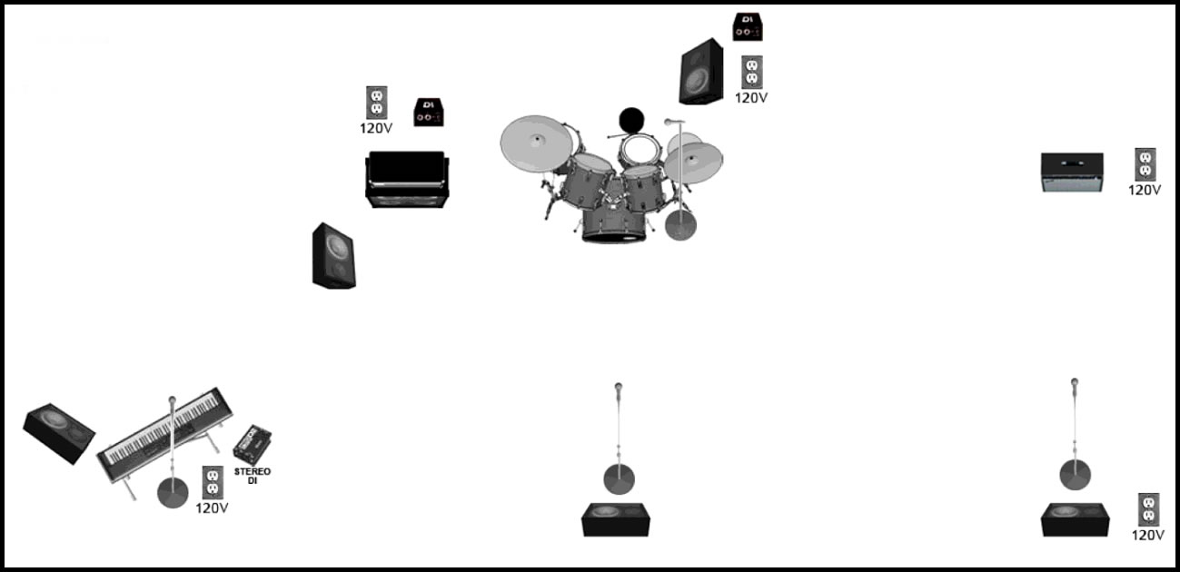

- HOSPITALITY

Dressing Room:
Presenter shall provide at least one private and secure dressing room for Artist’s sole use. This room should be capable of accommodating five (5) people and should be equipped as follows:
-Clothing rack and hangers
-Showers when possible with soap and towels with private toilet facilities to be used solely by Artist.
-Mirrors
-110 V. AC power outlets

Multiple performance dates will require laundry/dry cleaning services.

Catering:
Presenter shall provide five hot meals. Food coupons for Fairs and Festivals are acceptable as well. In the event that a hot meal cannot be provided then a mutually agreed meal per diem will be determined.

Presenter shall provide the following in the green room:
12 bottled waters
1 bottle of Makers Mark
2 bottles of red wine
Veggie platter with hummus
Fruit plate
5 stage towels.

Performers are flexible when it comes to snacks/meals. Please discuss suggestions during show advance.

Stage Drinks/Towels:
One case individual non-carbonated spring water bottles.
5 stage towels

- ACCOMODATIONS

Presenter shall provide 5 hotel rooms for 1-2 nights for each performance day.

- GROUND TRANSPORATION

Presenter shall provide ground transportation from airport-hotel-venue.

- CONTACT INFO

Show Advance/Tech:
Nic Johns (323) 605-5790
rumoursmgmt@gmail.com

