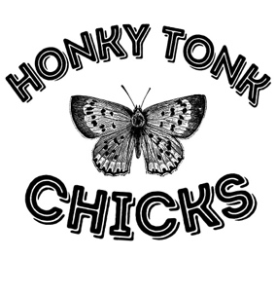

HONKY TONK CHICKS

HONKY TONK CHICKS is a powerhouse female vocal trio performing the greatest hits in Country Music! From today’s Top 40 all the way back to country classics. Audiences sing and dance along to the most popular party songs of all time! Featuring HITS like “Man! I Feel Like a Woman,” “9 to 5,” and “Tennessee Whiskey,” this trio takes audiences on a wild ride through their favorite songs from America’s most loved musical genre.

WE LOVE COUNTRY MUSIC!

We feature HITS like “Sweet Home Alabama,” “Tennessee Whiskey,” and “Man! I Feel Like a Woman,”. We take our audiences on a ride through their favorite songs from America’s most loved musical genre.
Featured artists include Dolly Parton, Shania Twain, Carrie Underwood, Elvis Presley, Garth Brooks & More.

“The Ultimate Country Music Party!”

“Dust off your cowboy boots for the Ultimate Country Music Experience! Dolly, Shania, Reba, and more – get ready to Boot Scootin’ Boogie the night away with the HONKY TONK CHICKS!”

Quotes:

“What a fun night! We knew every single song!”

“The girls are absolutely adorable! And those VOICES!”

“Line dancing to Garth Brooks was my favorite part of the night!”

“A true celebration of Country Music!”

“Their harmonies blew us away. And they didn’t miss a single step with those dances!”

“It’s like Coyote Ugly meets Destiny’s Child! Girl power at its best.”

