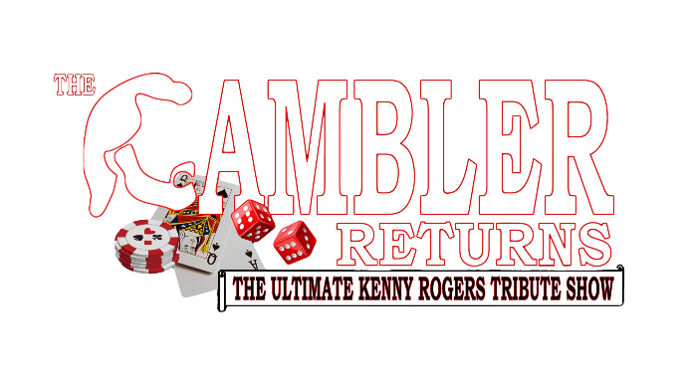
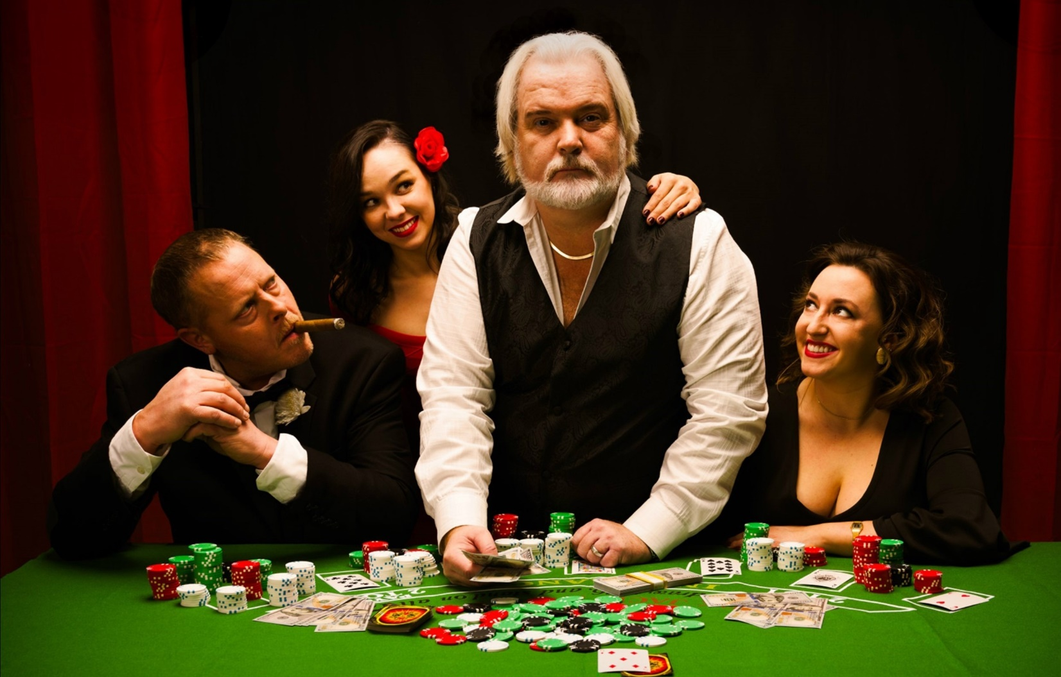Experience the music of GRAMMY® Award-winning superstar Kenny Rogers. A musical experience that spans over six decades of hit after hit song! His music is loved throughout the world and connects with generation after generation. Kenny’s command of the stage, heartfelt performances, gift for storytelling and distinctive voice are all on full display in this honoring recreation of his LIVE performances.

Join us as award winning country recording artist Alan Turner, recreates the magic of a night with Kenny in the Ultimate Kenny Rogers Tribute Show, The Gambler Returns. This full band top production show will take you on a musical journey through the career of an American Icon and Legend that sold over 120 million albums worldwide and racked up some 24 No.1 hits (including “The Gambler,” “Lady,” “Islands In The Stream,” “Lucille,” “She Believes In Me” and so many more). Audiences leave the performance wanting more.

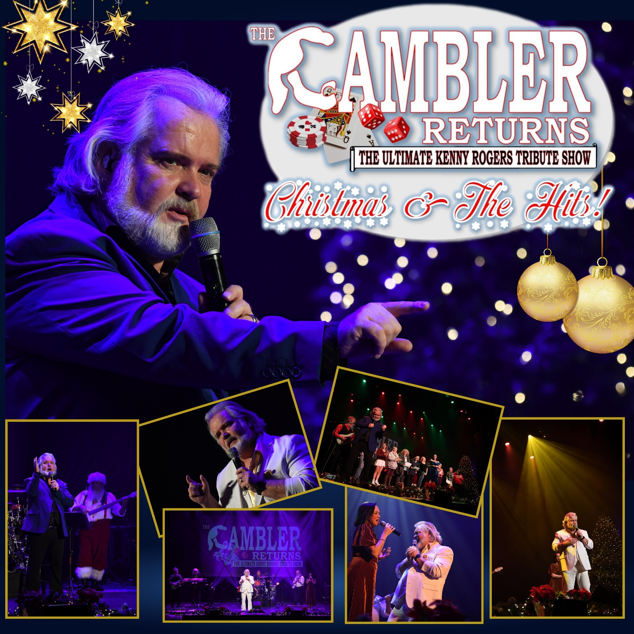

Rekindle that warm festive holiday spirit of Kenny Roger’s “Christmas and the Hits” show which became an annual tradition over the course of Kenny’s incredible career. Always a highly anticipated treat for the whole family, featuring heartwarming traditional and original holiday songs such as “Let It Snow,” “Winter Wonderland,” and “Mary Did You Know?” as well as all the hits everyone knows so well, “The Gambler,” “Lady,” “Islands In The Stream,” and so many more! Performed just the way the GRAMMY® Award-winning superstar would do it.

Join us as award winning country recording artist Alan Turner, recreates the magic of a night with Kenny in this full band top production show which takes you on a musical journey through the career of an American Icon and Legend that sold over 120 million albums worldwide and racked up some 24 No.1 hits. Audiences leave proclaiming that the Ultimate Kenny Rogers Tribute Show, The Gambler Returns, is an authentic must-see show!

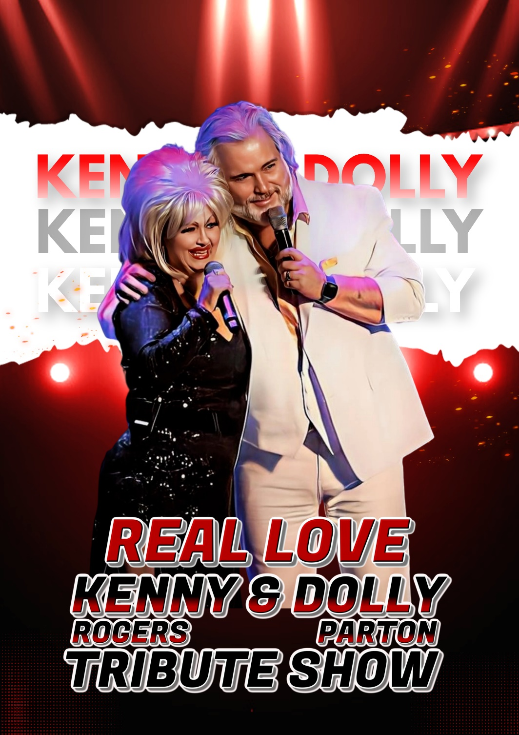

Experience an evening with country music’s favorite duo, Kenny Rogers and Dolly Parton. Audiences everywhere love this breath-taking recreation of a night with Kenny and Dolly performed by country music recording artists, Alan Turner and Laurie Lynn. Sit back and enjoy a musical journey that spans 6 decades! Experiencing the music of two American icons.

No other country music entertainers have garnered as much love and admiration as this duo have. Their on-stage charisma and close bond have endeared them to generation after generation of music lovers. Get ready to tap your feet and sing along to hit after hit with the Gambler and his Smoky Mountain Songbird sweetheart in “REAL LOVE” the Kenny Rogers & Dolly Parton Tribute Show! This is a must-see show!

