
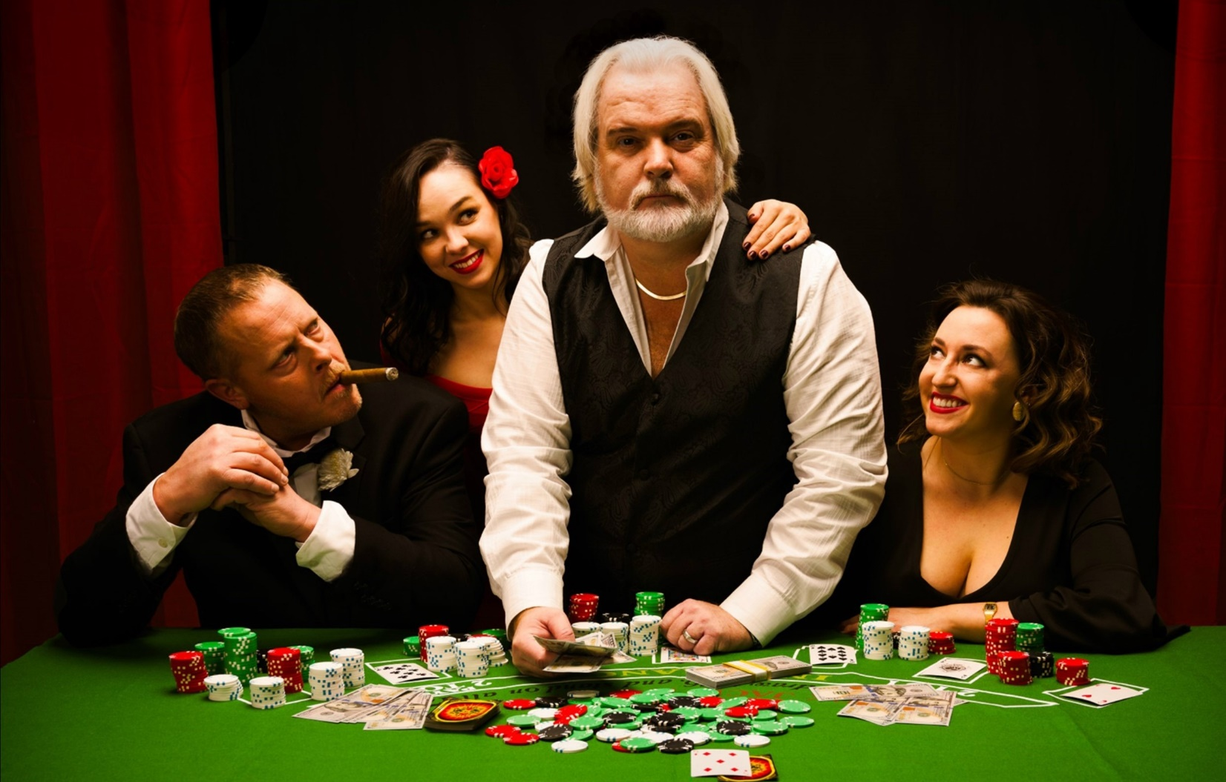Experience the music of GRAMMY® Award-winning superstar Kenny Rogers. A musical experience that spans over six decades of hit after hit song! His music is loved throughout the world and connects with generation after generation. Kenny’s command of the stage, heartfelt performances, gift for storytelling and distinctive voice are all on full display in this honoring recreation of his LIVE performances.
Join us as award winning country recording artist Alan Turner, recreates the magic of a night with Kenny in the Ultimate Kenny Rogers Tribute Show, The Gambler Returns. This full band top production show will take you on a musical journey through the career of an American Icon and Legend that sold over 120 million albums worldwide and racked up some 24 No.1 hits (including “The Gambler,” “Lady,” “Islands In The Stream,” “Lucille,” “She Believes In Me” and so many more). Audiences leave the performance wanting more.

TESTIMONIALS
"Everything went well here. The crowd loved the show. Alan did a great job engaging the crowd which always makes the show so much better."
Brian Hill, Managing Director, Smyrna Opera House, Smyrna, DE

"We got amazing feedback from the show, our audience loved it!"
Gera Ufkes, Operations Manager, Legacy Theatre, Carthage, IL
“The Gambler Returns” is a blast from the past, delivered with incredible skill and effort by the talented band behind it. A heartfelt reunion with an American icon combines with timeless hits to make for an unforgettable performance. Johnathan Condit, Entertainment Manager, Rhythm City Casino, Davenport, IA
"The Gambler Returns, starring Alan Turner, was a phenomenal concert experience, filled with the music of Kenny Rogers. Our bank clients were very pleased with the quality of the musicians and vocalists, and how they engaged with them so personally. I would highly recommend this show! It far exceeded my expectations." Sally Duke, Bank Travel Officer, Community First Bank of Indiana
"The Kenny Rogers Christmas Show with Alan Turner that we had at the Aplex in Alpena, MI was AMAZING! Alan did a fantastic job as Kenny, he was awesome with the crowd and everybody that came was talking about the show a couple of days following the show! Definitely a must see show."
Norm Sommerfeld, Facility Manager, Alpena Event Complex, Alpena, MI

"The audience was amazed at the show. It was the most Authentic tribute show we have booked!"
Randy Singer, Owner, Boca Black Box, Boca Raton, FL

"Alan walked out of the Green Room, my eyes were closed and when I opened them “The Gambler” was standing on my stage! 'Kenny' sang all his great holiday songs bringing tears to your eyes and joy to the heart. His performance was outstanding!"
Sharon Fisher, Vice President, Howell Opera House, Howell, MI

"The Gambler Returns was an amazing show, great people to work with, pleasant and down to earth, the State Theatre Patrons had a fantastic time."
Mike Bacigalupo, Chief Operating Officer, State Theatre of Bay City, MI

"The show was great! The band was really professional with the set up, Alan interacted well with our audience after the show, and sounded great. Audience comments were all positive. I can’t think of anything the band needs to change."
Owen Goslin, Executive Director, Cheboygan Opera House, Cheboygan, MI

