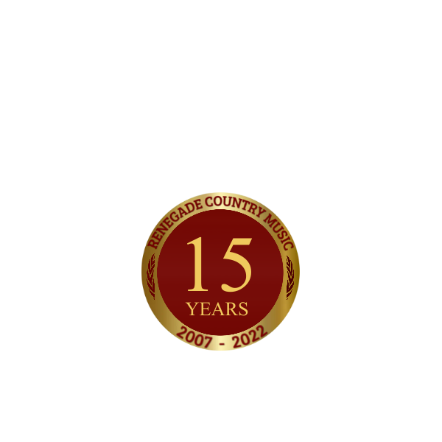

Not since Garth Brooks jumped off the stage and into people’s hearts has the country scene delivered such riveting entertainment as southeastern Michigan’s Alan Turner and his Steel Horse Band. His connection with his fans makes him stand out, and his rugged good looks, rich baritone vocals and the way he delivers the song to his captivated audiences has set him above the rest.
Alan found his love of music at a very young age. By six years old, Alan’s mother, a Sunday school teacher taught him to read music and play piano. Alan’s father also a singer/songwriter, was constant inspiration until his death when Alan was just ten years old.
“Shortly before his death, my father had given me Kenny Roger’s album The Gambler,” Alan explains. “I think it was the combination of my father’s musical influence and that old vinyl record of Kenny’s that led to my love of country music.”
This love is visible in Alan’s music in the way he can emotionally deliver each song and the story it tells on stage. For Alan that love came full circle in Las Vegas, Nevada in 2010 when he and the band had the honor of meeting Kenny and being his direct opening act.
In the years that have followed he has broken onto radio and television everywhere with his well-written and crafted songs, Bull Riding Babe (2015), Preacher Man and Me (2016), Windows & Mirrors (2017), Tennessee Twister (2019), That’s Why They Make Beer! (2020), Let Go (2020) and his recent release, Vintage (2021). Keep an eye out for his new music project, The Gambler Returns: The Ultimate Kenny Rogers Tribute Show, which is being booked all over the country!
Alan and the band have been thrilling crowds with his distinctly high energy Renegade Country Music! With a nonstop performance schedule there is no sign of him slowing down! This is one cowboy ya don’t want to miss!
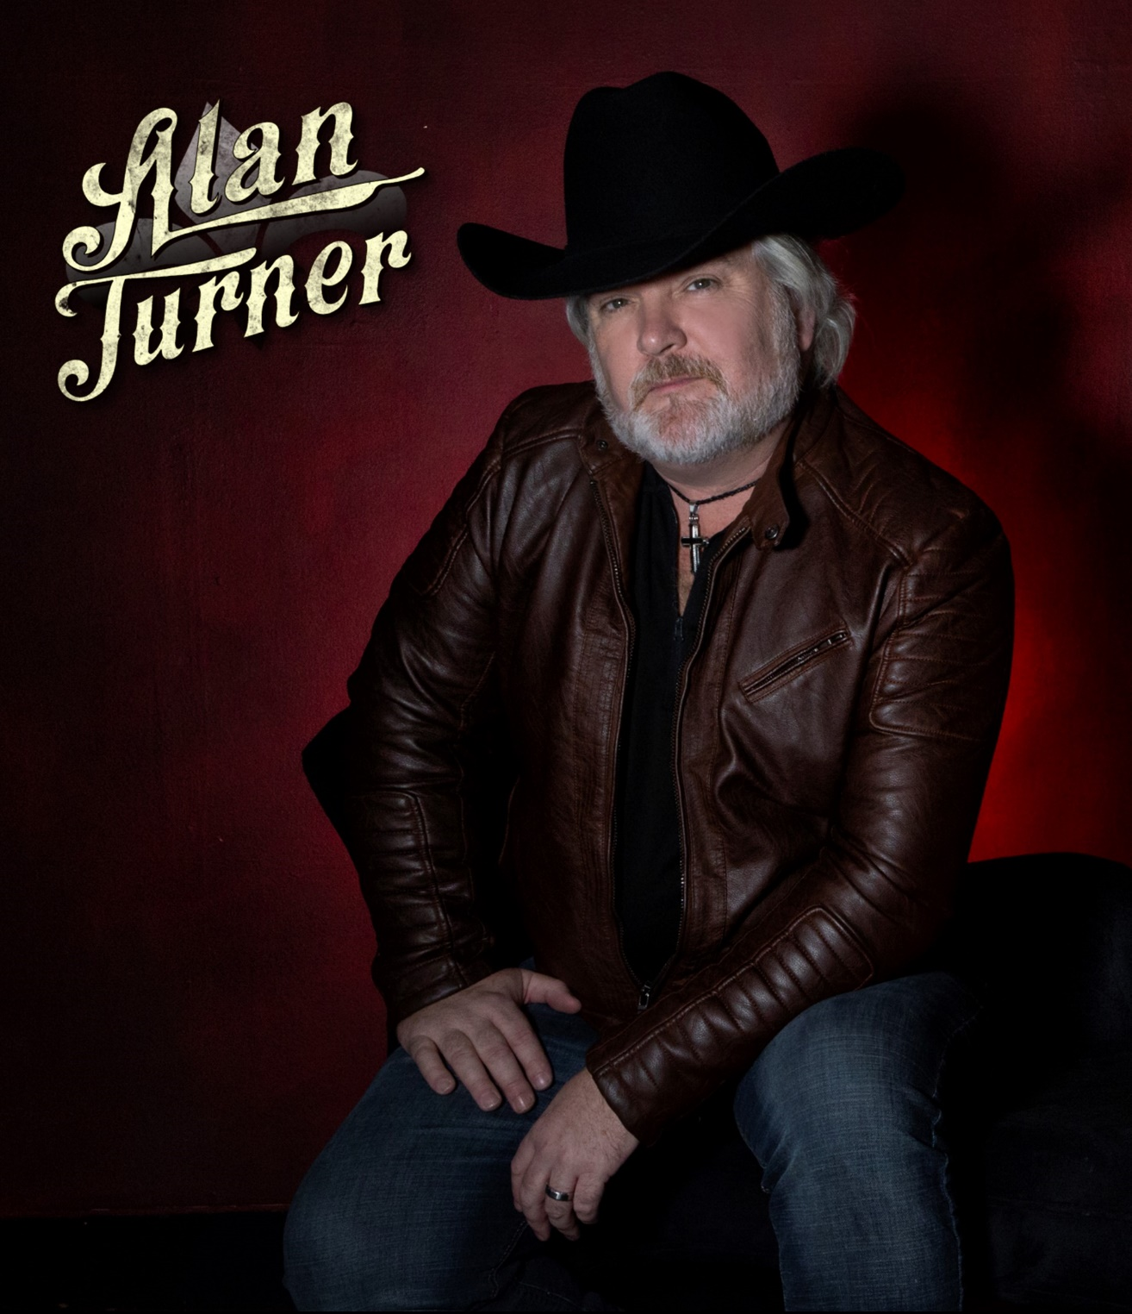
AwARDS and Acheivments

-INSPIRATIONAL COUNTRY MUSIC AWARD NOMINEE:
2015 NEW ARTIST OF THE YEAR AND 2016 VIDEO OF THE YEAR: “PREACHER MAN AND ME”
-DETROIT MUSIC AWARDS - 28 NOMINATIONS SINCE.
-Winner 2019 detroit music award Outstanding Country Recording: “Tennessee Twister”
-2022 inductee to the euro academy of country music hall of fame
-2022 inductee to the michigan country music hall of fame
-2022 appeared in along with having severalsongs in the movie, “Cupid’s CHristmas”
-Member of The Country Music Association (CMA)
-Has Performed on the Grand Ole Opry Stage (2018)
-Direct Opener for: Kenny Rogers, Glen Campbell, Montgomery Gentry, Lee Brice, Eli Young Band, Lonestar, David Lee Murphy, Jason Aldean, Craig morgan, blake shelton, lynyrd skynryd, blackberry smoke,
Oak ridge boys (and many more)
-MUSIC IS ON 60,000 TOUCH TUNES JUKEBOXES THROUGHOUT THE USA
-Music videos have aired to millions of households on CMT, TCN, the heartland network & many more
-Recieves radio play on fm & am stations as well internet radio all over the world

“Alan and the band deliver an energy packed, modern country show sure to blow the boots off any music lover of any age”
Tom Tesnow, The Magazine of Country Music

“Any young country artist coveting real success should go see an Alan Turner concert.” #SHOWMAN
Chuck Edwards, 99.5 FM WYCD Morning Show Host

“City of Lincoln Park, MI 2016 Summer Concert Series hails Alan Turner and the Steel Horse Band as an outstanding ‘Have-To-See’ band. We are impressed by the entertainment this group provided to our concert series. Looking forward to their next performance.”

Maureen Tobin, Recreation Coordinator, City of Lincoln Park, MI
www.AlanTurnerMusic.com

