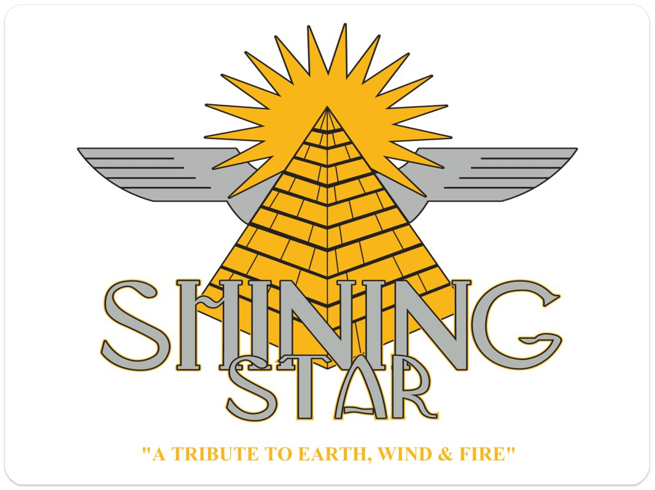

Shining Star played to a sold-out house at Freedom Hall and promptly validated why they are the premiere Earth, Wind, and Fire tribute band in the nation! Impeccable replication of the fabulous EWF sound, tasteful period-costumes, and smooth choreography made the show look and sound like an actual EWF concert. Our audience had a wonderful experience that evening and hoped to see them again!

Charles W. Sabey
Cultural Arts Supervisor
Freedom Hall

This band has such amazing energy. The entire crowd was up on its feet from start to finish, dancing and having a great time! I am working on our second engagement immediately!

Holly Marshall
Production Manager
Metropolis Performing Arts Centre

WOW.....That was a great show!!! They nailed it!! Very pleasant and easy going! That’s what I like!

Cheryl DeKam
Entertainment Coordinator
Grand Falls Casino

I heard you guys were GREAT and had a huge crowd. Congratulations!

Erin Bauer
Taste of Chicago
Programming Manager

When working with a group of musicians with the talent and stature of Shining Star, I normally encounter egos and attitudes. We work with cover bands to national touring recording artist. But, upon meeting and setting up Shining Star, my crew and I were overwhelmed at how down to earth, professional, and all around good people this band is!! One of the best bands we've worked with. Look forward to working with them up again.

Marvin Ervin
President and CEO
Narvelle Media

Honestly, when Shining Star came across my desk I could not believe there could be a band that could recreate the Earth, Wind and Fire magic. They totally exceded my expectations! I've had The Commodores, Tower of Power, and countless acts from that era, and I must say that Shining Star's show was up there with the best of them. I've hired them on two occasions and I am working on a third.

Rich Bentler
Entertainment Manager
Riverside Casino and Golf Resort

