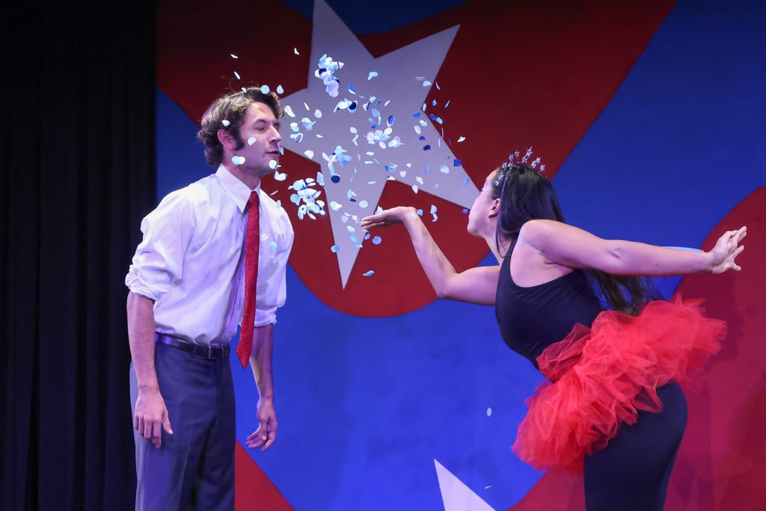
The Election Fairy (Cristina Florez) tells A Republican Candidate (Trevor Keyfauver) how to get to MAGA Gaga Land in Capitol Comedy’s TWO CHEERS FOR DEMOCRACY. (Photo credit: John Dlugolecki)
And after all that intensity, it was time for some off-the-wall political comedy when the Capitol Comedy troupe stopped off in Los Angeles to preview their all-new review with songs, TWO CHEERS FOR DEMOCRACY. Filled with comedy sketches, song parodies, mock commercials and fake news updates from across the political spectrum, Capitol Comedy serves up a humor-filled plate of hard truths, sparing no one from left, right or center. It’s all done in the spirit of fun with parodies of familiar tunes as well as some original music, accompanied by music director/pianist Brenda Varda.
Washington-based writer-director-producer Nicholas Zill assembled this troupe of exceptionally gifted sketch performers, singers and impressionists to fill a political comedy vacuum created by the retirement of the group Capitol Steps. Director Caitlin Hart is blessed with an energetic cast of 10, with five performing all the characters in each performance by always moving, changing costumes and personas at the drop of a hat. The troupe visiting Los Angeles on August 28 included Shefali Deshpande, Travis Jo Dixon, Cristina Florez, Bella Gil, Trevor Keyfauver, Adam LaSalle, Alivia Long, Julia Mack, Aaron Matijasic, and Sarah Oliver.
Be prepared to laugh at their antics on topics including voting regulations, how to fool the public to get elected; the Supreme Court overturning Roe vs. Wade; the purging of books from public schools; the effects of the COVID-19 epidemic on parents, teachers, and schools; the promotion of “protest tourism”; and even the ever-expanding list of groups and topics about which one may not joke, including Vladimir Putin singing “If You’re Good to Putin, Putin Good to You” to a well-known song from the musical “Chicago.” Ending the 90-minute show with musical reminders “Meet Me at the Midterms” and “When Those Souls go to the Polls” will hopefully encourage everyone to remember to vote this November.
Capitol Comedy’s 2022-2023 TWO CHEERS FOR DEMOCRACY national tour includes bookings in California, Alabama, Washington State, Oregon, Colorado, New Jersey, Pennsylvania, New Hampshire, Maryland, and Washington, D.C. Visit www.cityinaswamp.com/capitol-comedy for more information on the troupe and its upcoming show dates.
