Biden My Time Review – The Mock in Democracy
October 6, 2021 Elaine Mura Entertainment Loa Angeles, CA - Splash Magazines
Bella Gil as Alexandria Ocasio-Cortez, Travis Joe Dixon as Joe Biden, and Alivia Long as Kamala Harris in BIDEN MY TIME - Photo by Josh Fong
Spread the love
Soon we’ll all be hearing more about Capitol Comedy, a newly-formed troupe of talented sketch performers, singers, and impressionists with one goal in mind: to poke fun at today’s political realities. And not a moment too soon. It doesn’t matter if they’re targeting left, right, center, Red, Blue, or somewhere in between. All corners of the political spectrum offer ripe pickings for a comedy group taking the pulse of today’s conflicted world. The brainchild of Washington-based writer/director/producer Nicholas Zill, Capitol Comedy takes aim at Washington politicians through sketches, songs, song parodies, and brief video segments. Audience Alert: Nobody and nothing is sacred as Capitol Comedy starts the satire steamboat is on its merry way.
Aaron Matijasic as Bernie Sanders and Daniel Amerman as Joe Biden – Photo by John Dlugolecki
Directed by Caitlin Hart with music direction and piano by Brenda Varda, BIDEN MY TIME takes some of our all-time favorite songs like “76 Trombones,” “Some Enchanted Evening,” “Hello Dolly,” and “Camelot” and gives them a few tweaks and a new set of lyrics which will have the audience rolling in the aisles. Think “76 Skin Tones” as Biden introduces his new Cabinet or “Some Election Evening” as a liberal staffer discovers that love does not conquer all.
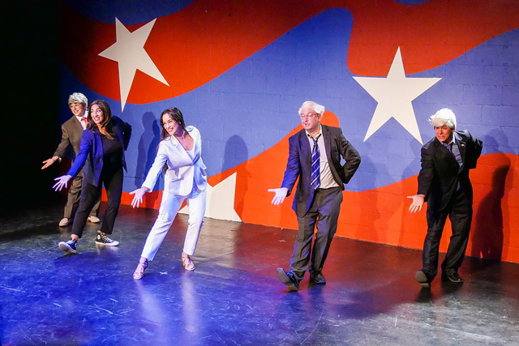The Cast of BIDEN MY TIME – Photo by John Dlugolecki
This is a cast that knows its way around comic satire, clowning, and slapstick – and they can sing and dance too. A spunky Joe Biden (Daniel Amerman) leads the way as the Dems invade Washington – with Kamala Harris (Shefali Deshpande) at his side. But it wouldn’t be today’s administration without a few liberals entering the fray as Alexandria Ocasio-Cortez (Cristina Florez) kicks up her heels while she kicks Congress on its bottom and Bernie Sanders (Aaron Matijasic) sounds his mantra of “MediCare for All.” Not to be outdone, Mitch McConnell (Joy Mamey) puts in an appearance while Jeff Bezos and Rachel Maddow look on. Capitol Comedy even managed to find some look-alikes to take on various roles, with special kudos to Matijasic’s Bernie Sanders, who looks, sounds, and feels like the real article. BIDEN MY TIME is double cast to keep the humor fresh and the performers energetic. If you’re longing to see “Two Old Guys (Biden and Sanders)” do a soft-shoe or Kamala Harris lamenting that maybe becoming Vice President wasn’t such a good idea, then you’re sure to find BIDEN MY TIME the epitome of fun.
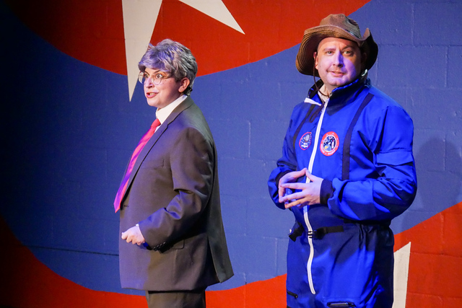Joy Mamey as Mitch McConnell and Aaron Matijasic as Jeff Bezos – Photo by John Dlugolecki
From ridiculous to hilarious, Capitol Comedy nails it with sidesplitting stupidity and uproarious humor. This quirky, eccentric production puts the spotlight on a witty, waggish Washington as it dissects today’s real Comedy Central right here in D.C. BIDEN MY TIME is an entertaining, timely, and clever production which will keep audiences on their toes while they chuckle and chortle.
BIDEN MY TIME presented two special preview performances on October 3, 2021 at 12 p.m. and 2:30 p.m. at the Zephyr Theatre, 7456 Melrose Avenue, Los Angeles, CA 90046. Capitol Comedy troupe plans to go on the road soon, with Washington, Chicago, and other hot spots in its sights. Keep an eye out for when they return to Los Angeles.

